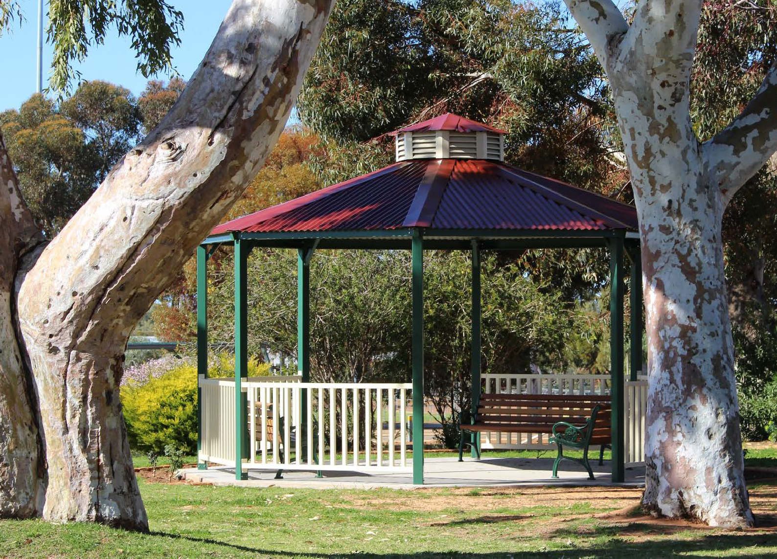

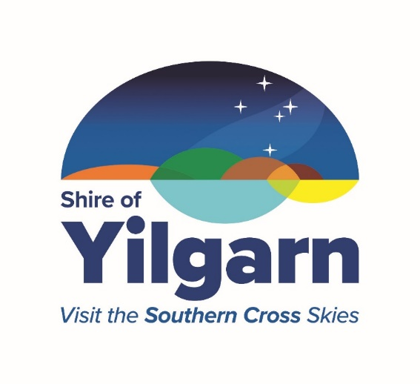

Strategic Community Plan
2020-2030

1
Shire of Yilgarn Strategic Community Plan 2020-2030
CONTENTS

Message from Shire President 2

Introduction 3
Shire Profile 5
Community Profile 6
Other Agencies Strategies and Plans 7
Shires Role 9
Creating our Strategic Community Plan 10
Strategic Direction 11
Social Objectives 13
Economic Objective 15
Environmental Objectives 16
Civic Leadership Objectives 17
Monitoring and Reporting 18
2

Shire of Yilgarn Strategic Community Plan 2020-2030

MESSAGE FROM THE SHIRE PRESIDENT

Welcome to the Shire of Yilgarn Strategic Community Plan 2020 – 2030, the guiding document for the Shire of Yilgarn over the next 10 years.

It is the responsibility of all Local Governments in Western Australia to demonstrate through their strategic plan, on-going planning for the social, environmental and economic future for the whole of the Shire.

This Plan is our road map to a secure future and will provide guidance to our Council as we make important decisions on behalf of the community over the next 10 years. It incorporates our vision and our aspirations for the future and will allow the Council to prioritise service delivery and projects that have been identified as important to community members.

This Plan outlines the long-term vision and values of the community of the Shire of Yilgarn whilst also acknowledging the requirements and resourcing capabilities of the Shire. It is part of our fulfilment of the Integrated Planning and Reporting (IPR) Framework. Whilst the Strategic Community Plan is a ten- year plan, it is not fixed for ten years as it would be long out of date by then. Rather, it is a “rolling” plan which is reviewed every two years. The two- yearly reviews alternate between a minor review (updating as needed) and a major review (going through all the community consultation steps again).

The Plan could not have been produced without the involvement of the local Yilgarn community and I am very grateful to those members of the community who became involved and took the time to provide input for the plan. Your responses gave Council valuable insight towards the priorities and visions for the future of the Shire of Yilgarn.

Our Council is committed to delivering the vision outlined in this Plan and we look forward to working with the community to bring it to fruition.

The Strategic Community Plan was adopted by Council on 18 June 2020.

Cr Wayne Della Bosca Shire President

3

Shire of Yilgarn Strategic Community Plan 2020-2030

INTRODUCTION

What is the Strategic Community Plan
The Strategy Community Plan is the highest level planning document in the Integrated Planning and reporting process. This Plan is designed to be a “living” document that guides the development of the Shire of Yilgarn community for the next ten (10) years.
One of the key features of the Strategic Community Planning process is community engagement and the part it plays in influencing the Shire’s strategic direction as it seeks to achieve the community’s long term vision and aspirations.
Strategic planning is a recurring process, requiring constant refinement and review. Every second year a desktop review of this Plan is scheduled to occur which will alternate with a comprehensive review every four (4) years to ensure the Plan remains in line with the community’s vision, aspirations and objectives.

Structure of the Plan
Based on community engagement, the Plan sets out the vision for the Shire’s future and captures the community’s aspirations and values. A strategic objective has been developed for each of four key themes of community interest, being:

- Environment: Protecting, utilising and enhancing our beautiful natural heritage
- Social: An inclusive, secure and welcoming community that encourages families, youth and the aged to remain and contribute to our Shire in the long term;
- Economic: A prosperous future for our community; and
- Civic Leadership: Dynamic and visionary leadership guiding our community into the future.

Desired outcomes for each objective have been determined and strategies to meet the objectives established. In undertaking the review, the Shire had regard for the community’s feedback, current and future resources, strategic performance indicators and demographic trends.

How the Plan will be Used
The Plan outlines how the Shire, will over the long term, works towards a brighter future for the Shire of Yilgarn community as it seeks to achieve its vision inspired by the community’s aspirations for the future.

Looking to the future, the Strategic Community Plan will influence how the Shire uses it resources to deliver services to the community. The Plan forms the primary driver for all other planning undertaken by the Shire.

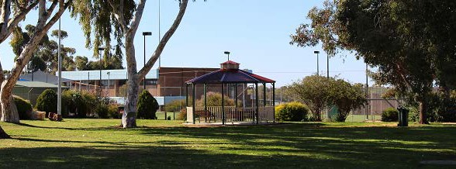Shire of Yilgarn Strategic Community Plan 2020-2030

Corporate Business Plan
4

Annual Budget

Integrated Planning and Reporting Framework

The Integrated Planning and Reporting Framework is shown in the diagram below. The idea behind the framework is to ensure that the Council’s decisions take the community’s aspirations into account and deliver the best results possible with the available resources.
The Strategic Community Plan sets the scene for the whole framework – it expresses the community’s vision and priorities for the future and shows how the Council and community intend to make progress over a ten year period.
Detailed implementation for the next four years is covered in the Corporate Business Plan. The “Informing Strategies” – particularly the Long Term Financial Plan, Asset Management Plans and Workforce Plan – show how the Plan will be managed and resourced.
The Annual Budget relates to that year’s “slice” of the Corporate Business Plan, with any necessary adjustments made through the Annual Budget process

Strategic Community Plan

INFORMING STRATEGIES
Finance Workforce Assets Services
Issue Specific Strategies

Shire of Yilgarn Strategic Community Plan 2020-2030
5

Shire Profile

The Shire of Yilgarn is located in Western Australia’s Eastern Wheatbelt and covers a vast area of 30,720 square kilometres. Southern Cross, the main administrative centre of the Shire is located on the Great Eastern Highway, 370 kms east from the Perth metropolitan area.

The Shire has a population of approximately 1,173 (2021 ABS data) people, however it serves well over that figure due to the resources industry in the Shire and the fly in fly out / drive in drive out nature of work. The Shire is well known as the Gateway between the Wheatbelt and the Goldfields.

The name ‘Yilgarn’ is aboriginal for ‘white stone’ or “Quartz”.

As stated above, the town of Southern Cross is the main centre, and houses the administration of the Shire, however, there are numerous other smaller townsites throughout the Shire, including, Bodallin, Bullfinch, Ghooli, Koolyanobbing, Marvel Loch, Moorine Rock, Mt Hampton and Yellowdine.

In 1891, the Yilgarn Road Board was gazetted, and in 1918, it merged with the Municipality of Southern Cross. In 1961 it became the Shire of Yilgarn following the introduction of the Local Government Act 1960.

The Shire provides roads, recreational facilities, funding for medical services, parks and gardens, street lighting, and waste collection amongst other community services and infrastructure. Our elected members advocate for the interests of the community and make decisions about where and how development can occur.

Agricultural production and mining activities (gold, iron ore, lithium, and salt) are the main industries in the Shire of Yilgarn

President
Cr Wayne Della Bosca
Deputy President Cr Bryan Close Councillors
Cr Jodie Cobden Cr Gary Guerini Cr Phil Nolan
Cr Linda Rose
Cr Lisa Granich

Shire Snapshot 21/22
Total Area 30,720km²
Sealed Roads 338km
Unsealed Roads 2445km
Number of Employees 47
Number of Electors 653
Rates $4.16m
Budget $4.07m
Financial Assistance Grants
General $2.10m
Roads $1.55m
Other Grants $2.95m
Capital Expenditure $5.07m
Operating Expenditure $11.3m
Excluding Depreciation $7.31m
Depreciation $3.97m
Value of Assets $260m

6

Shire of Yilgarn Strategic Community Plan 2020-2030

Community Profile¹
The Shire of Yilgarn community has experienced steady decline in population over the past several years. Currently, the population is at 1,173 with around 62% male and 38% female.

The age profile of the Shire of Yilgarn from 2001-2021 is as follows:

The median age of the Shire of Yilgarn population in 2021 was 47.
The Shire of Yilgarn population has an unemployment rate of 6.6% compared to the Australian unemployment rate of 6.9% (2016 ABS data). The primary employment sectors in the Yilgarn are mining, agriculture and construction.
¹Australian Bureau of Statistics 2021, Yilgarn (Local Government Area), Basic Community Profile

Shire of Yilgarn Strategic Community Plan 2020-2030
7

Other Agency strategies and plans
The Shire of Yilgarn does not exist in isolation and is part of the Wheatbelt Region and the
broader State of Western Australia. This section provides an overview of some of the key strategies and plans that influence the Shire’s operating environment.

Wheatbelt Development Commission Wheatbelt Blueprint
The Wheatbelt Blueprint was developed by the Wheatbelt Development Commission, and
reviewed in 2015, as a road map to guide and assist the Region to deliver its potential. The Blueprint is based on a strong analysis of existing infrastructure and services across the Region.
The Vision for the Region outlined in the Blueprint is: “The Wheatbelt is a key contributor to Western Australia’s prosperity. The Region’s prime location, diverse economy, clever people, vibrant communities and unique natural environment offer a high quality of life and will attract global innovators and investors.”
The Blueprint is structured around the four pillars of diverse economy, clever people, vibrant communities and unique natural environment. Each pillar has a suite of aspirations & targets, outcomes, focus areas and priority actions.

8

Shire of Yilgarn Strategic Community Plan 2020-2030

Central East Sub-Regional Economic Strategy
The Central East Sub Regional Economic Strategy (2012) was commissioned by the Wheatbelt Development Commission and establishes a framework for the promotion and facilitation of economic and population growth across all towns in the sub-region.
The Strategy identifies economic opportunities for the Shire of Yilgarn in the areas of:
- Broadacre Agriculture
- Mining and Support Services
- Population Services
It also identifies a number of actions that the Shire of Yilgarn should undertake to effectively leverage these economic opportunities.

Regional Development Australia - Wheatbelt Wheatbelt Youth Strategy
The Wheatbelt Youth Strategy was developed by Regional Development Australia,
Wheatbelt. The framework aims to ensure that key youth stakeholders in the region have a common focus for implementing initiatives that will contribute to improving opportunities and the wellbeing of youth.
The vision guiding the framework is: “All Wheatbelt young people matter – to themselves, to the community – now and into future”.
The framework is structured around four priority areas with objectives, strategies, actions and stakeholders being detailed for each of these areas:
- responsible behaviour
- education, training and employment
- community, parenting and families
- health and wellbeing

Regional Development Australia Wheatbelt – Other Relevant Strategies/Plans

- The Need for Reform – Aged Care in the Wheatbelt Region
- Wheatbelt Digital Action Plan
- Entreprenurial Innovation in the Wheatbelt
- Wheatbelt Regional Children’s Services Plan
- Youth Connections Program Legacy Document
- Y20 Wheatbelt Summit Report

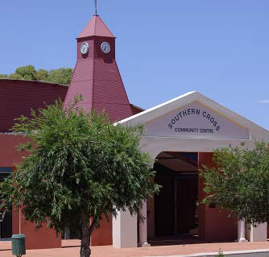

Shire of Yilgarn Strategic Community Plan 2020-2030
9

Shires Role
Local governments operate under Statute but also with some discretion. The four primary roles the Council has are:

Civic Leadership
Delivery of facilities and services This role includes services like parks and gardens, roads, footpaths, drainage, recreation and
cultural facilities, and events.
Most services are based on infrastructure like parks and playgrounds, roads and buildings. Maintenance and renewal of these infrastructure assets is a vital part of Council’s service delivery role.
Some services are non-asset based, such as events and community information.
Council has a role as civic leader in the community. With strong leadership and community support, the Council can achieve much more than just through its own direct service delivery.

Regulation
Influence
Influencing the decisions of others who do or can contribute to positive community outcomes in the Shire of Yilgarn is an important role. Advocacy to State government for recognition, funding, favourable policies or other forms of support is a good example of this role.
Local governments have specific regulatory responsibilities that are vital for community wellbeing. For example, they have a regulatory and enforcement role in public health (e.g. licensing and monitoring food premises), the appropriateness and safety of new buildings, and the use of land. These areas are subject to regulation because they have the potential to impose costs or adverse effects on others (e.g. food poisoning, injuries or hazardous activities too close to population). In many cases the rights of those wishing to operate and the rights of those who may be affected or consider themselves to be affected is a delicate balancing act.

Shire of Yilgarn Strategic Community Plan 2020-2030
10

Creating our Strategic Community Plan

Community Engagement Responses

The Shire of Yilgarn received 40 written responses;
The Strategic Community Plan process
commenced in August/September 2019 and focused on obtaining feedback from the community via a survey and key
business stakeholder interviews.
The campaign was advertised in the
local newspaper, the Shire of Yilgarn website and Community Resource
400 paper surveys were printed and
delivered by mail in the form of - “To the Householder”.
The survey was also available online using
SurveyMonkey, linked from the Shires
website.
  - 27 Mailed Survey Responses
  - 13 SurveyMonkey Responses
  - 11 One-on-one Key Stakeholder Interviews
The community response surveys were from a range of ages as below

Under 25 25-39 40-64 Over 64

Following the closing date for the community survey responses a Strategic Community Plan Workshop was held in February 2020.
13 community residents attended the workshop.

Key priorities arising from the community survey were identified.
Included in the community workshop was review of the Shire of Yilgarn vision, prior to the workshop residents were encouraged to view alternative visions or provide wording.

Shire of Yilgarn Strategic Community Plan 2020-2030 11

Strategic Direction
Our Vision
We are a proud agricultural and mining based economy, providing opportunities for our residents that will build an inclusive and prosperous community in the future.

Our Mission

”The Shire of Yilgarn will deliver quality services, facilities and representation in order to achieve our Vision”.

Key points of the plan
The Council have engaged the community in setting a vision for the coming decade. This plan sees existing services and facilities continue highlighting the priorities that Council will focus on over the coming ten years to achieve the vision:

- Embracing Technology | - Community Involvement
- Supporting Tourism | - Advocacy for essential Services
- Supporting Local Businesses
The detailed implementation of this plan for the next four years will be presented in the Corporate Business Plan.

Strategic issues facing the community
The following issues were identified as particularly significant challenges for the community in the coming years. The participants in the community engagement process highlighted these issues and they have been taken into account in preparing this Plan:
- maintaining our population
- economic development and diversity
- “ageing in place”
- high community expectations
- reduction in essential services
- climate change
- local employment opportunities
- maintaining and renewing our community assets within our own financial resources

Shire of Yilgarn Strategic Community Plan 2020-2030
12

Our Values
We will promote and enhance the following values in all our relationships with our community:
Honesty in our dealings Integrity in our actions Consistency in decision making Teamwork in our operations
Respect to others and their decisions Caring for people in our community Commitment to decisions and roles Responsive to the needs of others Effective Communication with all

Key Issues Raised at Community Engagement Workshop
- Improve Entrance Statements to Southern Cross – Incorporating integration of farming and mining and to include smaller versions for surrounding townsites
- Signage at Shire to be improved and incorporate Tourism identification
- Continue development of Constellation Park
- Investigate Solar Powered de-salinator to improve water security and supply
- Investigate options for the development of Light/Heavy Industrial land for major industries
- Develop and enhance Lake Polaris for tourism potential

13

Shire of Yilgarn Strategic Community Plan 2020-2030

Social Objectives

An inclusive, secure and welcoming community that encourages families, youth and the aged to remain and contribute to our Shire in the long term.

Outcome 1.1 Maintain / increase percentage of residents engaged in recreation, cultural and leisure activities for all demographics in the Shire
1.1.1 | Continue to implement and support community programs
1.1.2 | Provide and maintain high quality community infrastructure (recreation centre, oval, bowls, swimming pool, library, community centre, halls)
1.1.3 | Support the provision of child care facilities within the community
1.1.4 | Explore opportunities for youth programs
1.1.5 | Provide support to local sport, recreation and community groups

Outcome 1.2 Retention and upgrade of the current health and education services and infrastructure (Shire and State responsibility)
1.2.1 | Value and promote educational opportunities to retain families and youth in the Shire
1.2.2 | Maintain quality infrastructure for health providers (medical centre, housing)
1.2.3 | Lobby state and federal government for improved health infrastructure
1.2.4 | Support continued incentive funding for a GP in the Shire
1.2.5 | Continue to provide free use of facilities for use by service providers (Chiropractor, Physiotherapist, Veterinarian)

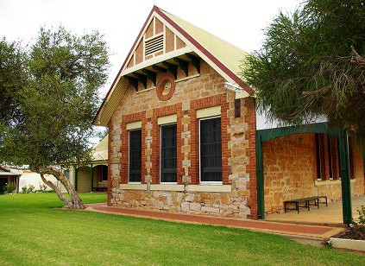Shire of Yilgarn Strategic Community Plan 2020-2030 14

Outcome 1.3 High Quality and well maintained Ages Care facilities

1.3.1 | Continue to manage, refurbish and maintain the Homes for the Aged
1.3.2 | Support the Central East Aged Care Alliance (CEACA) Independent Living Unit’s precinct in Southern Cross
1.3.3 | Manage and maintain the Southern Cross Senior Citizens Centre

Outcome 1.4 Maintain a liveable, safe and secure community

1.4.1 | Retain a strong focus on community safety and crime prevention
1.4.2 | Advocate and actively support emergency management and services in the district

15

Shire of Yilgarn Strategic Community Plan 2020-2030

Economic Objectives

A prosperous future for our community

Outcome 2.1 Improved telecommunications infrastructure

2.1.1 | Continue to lobby for improved telecommunications infrastructure to eliminate blackspots in the Shire
2.1.2  Outcome | Continue to re-broadcast FM Radio & TV channels for the Southern Cross community  2.2 Businesses in the Shire remain competitive and viable

2.2.1 | Continue to provide an efficient and effective approval processes
2.2.2 | Support the local business community and promote further investment in the district, including opportunities for industry growth and development
2.2.3  Outcome | Continue to support and manage the Community Resource Centre  2.3 Quality and affordable housing is available

2.3.1  Outcome | Continue to invest in housing to attract professionals to the region to attract and retain professionals and young people in the Shire  2.4 Tourism opportunities are maximised

2.4.1 | Continue to manage and promote the Southern Cross Caravan Park
2.4.2 | Continue to support the Southern Cross Museum
2.4.3 | Re-establish a Yilgarn Tourism Committee to advise/recommend to Council on actions to promote tourism in the district
2.4.4 | Improve Visitor information services
Outcome 2.5 Safety and quality of transport networks are maintained and improved
2.5.1 | Continue to maintain and upgrade our road network
2.5.2 | Continue to maintain the Southern Cross Airstrip and facilities

16

Shire of Yilgarn Strategic Community Plan 2020-2030

Environmental Objectives

Protecting, utilising and enhancing our beautiful natural heritage

Outcome 3.1 Satisfaction with waste management services and recycling processes
3.1.1 | Establish and maintain environmentally sound regional waste facilities to cater for the Shires long term waste disposal requirements
3.1.2 | Continue to provide & promote recycling services, including fortnightly household pick up and e-waste collection

Outcome 3.2 A valuable natural environment where community members in all industries and government invest in landcare initiative
3.2.1 | Lobby for continued investment in landcare and conservation

Outcome 3.3 Satisfaction with sewerage services

3.3.1 | Continue to maintain current sewerage systems in accordance with licensing requirements and asset management plan
3.3.2 | Continue to use recycled water for use at the Southern Cross Oval and Constellation Park

Outcome 3.4 Increase investment I renewable energy (private and/or public
3.4.1 | Investigate the feasibility of renewable energy projects to cater for the long term energy needs of the community

17

Shire of Yilgarn Strategic Community Plan 2020-2030

Civic Leadership Objectives

Dynamic and visionary leadership guiding our community into the future

Outcome 4.1 A trustworthy and cohesive Council that functions efficiently and effectively
4.1.1 | Ensure compliance whilst embracing innovation and best practice principles.
4.1.2 | Maintain a high level of corporate governance, responsibility and accountability.

Outcome 4.2 A community that respects and values Council staff and elected members
4.2.1 | Ensure adequate training programs for elected members and staff.
4.2.2 | Provide leadership to the community, staff and wider region

Outcome 4.3 Positive and productive regional partnerships

4.3.1 | Actively participate in regional forums including Great Eastern Country Zone WALGA, Wheatbelt East Regional Organisation of Councils, Wheatbelt Communities and CEACA

18

Shire of Yilgarn Strategic Community Plan 2020-2030

Monitoring and Reporting

The Shire of Yilgarn will conduct a Strategic review every two years alternating between minor and major strategic review
Services and facilities provided by the Shire have been linked to the relevant strategies in the Strategic Community Plan in the following table. The table provides a connection between the services and facilities and the desired outcomes and community vision for the Shire of Yilgarn.

Social | Economic | Environmental | Civic leadership
An Inclusive, Secure and welcoming community that encourages families, youth and the aged to remain and contribute to our Shire  in the long term | A prosperous future for our community | Protecting, utilising and enhancing our beautiful natural heritage | Dynamic and visionary leadership guiding our community into the future
- Medical Services (Doctor) | - Museum | - Animal Control | - Emergency Management
- Community Resource Centre | - Tourism& Visitor Services | - Fire Prevention & Control | - Public Health
- Child Care Centre & Playgroup | - Area Promotion | - Pest Control (mosquitos) | - Police Licencing
- Senior Citizens Centre | - Caravan Park and Motel | - Refuse Collection & Sites | - Governance
- Aged Housing | - Road maintenance & construction | - Sewerage | - Local Laws
- Community Bus | - Standpipes | - Town Planning
- Swimming Pool; |  | - Cemetery
- Sport and Recreation |  | - Public Toilets
- Library |  | - Street lighting
- Community Development |  | - Footpaths & verges
- FM Radio Re- Broadcasting |  | - Townscapes
 |  | - Building control
 |  | - Biosecurity

19

Shire of Yilgarn Strategic Community Plan 2020-2030

Document Owner CHIEF EXECUTIVE OFFICER

Adopted: | JUNE 2020
Last Review: | SEPTEMBER 2022
Date for next Review: | JUNE 2024

