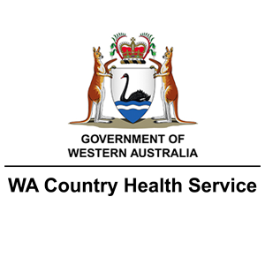
Vulnerable Persons Register

The Shire of Yilgarn and Southern Cross Hospital are compiling a comprehensive list of vulnerable people within the Shire of Yilgarn, of whom may need assistance during emergency situations, such as prolonged power outages, severe storms, bushfire or other significant emergency events. Assistance may be a simple check in, or more targeted assistance, such as equipment assistance, transportation to hospital or medication storage.
Those interested in being included in the register are asked to complete the information below and over-page, and return to either the Southern Cross Hospital, or Shire of Yilgarn offices.
It is important to note, in the event of an emergency those deemed at most risk will be prioritised. Whilst every endeavour will be made to contact those deemed vulnerable, there can be no guarantee provided as there may be other priority actions being undertaken. As such, even if you have registered, if you need urgent emergency support, you must call 000.
By completing this form, I am giving consent to the Shire of Yilgarn and Southern Cross Hospital keeping a record of my details to use during an emergency event.
Name:
Address:
Mobile:
Landline:
Email:
Next of Kin/Support Person Name:
Next of Kin/Support Person Mobile:
Signed:

Please tick Either “Yes” or “No” for the following.
Vulnerability Details | Yes | No
- Do you live alone?
- Do you have other people (partner, family friend etc) living at your residence?
- Do you have support in the home from NDIS, CHSP, HCP or other?
- Do you have access to digital technology such as IPad, PC, or mobile?
- Do you have people in the surrounding area who can check on you?
- Do you have a medical condition that could worsen or deteriorate during a prolonged power outage of 12 hours or more?
- Do you have access to transport if you are required to evacuate?
- Do you have access to the Yilgarn WHISPIR service for local warning information (email/SMS)?
- Do you wish to be contacted in the event of an emergency, for a welfare check

If you answered YES to Questions 1, 6 and 9, and NO to Questions 5 and 7, then your situation indicates you would benefit from being on the Vulnerable Persons Register.

Queries: Donna Newbury 0417 921 884
Lodgement: Shire of Yilgarn
In Peron: Shire of Yilgarn Administration – 23 Antares Street, Southern Cross
Email: yilgarn@yilgarn.wa.gov.au
Post: PO Box 86, Southern Cross WA 6426

